## Experiment No.: 1

**Name : Soham Kishor Walam** **Roll No: D102**

**AIM: To study types of cables** (Twisted Pair Cable, Co-axial cable, fiber optic cable)**,** connectors (RJ-45, BNC connector) **and Networking devices** (Hub, Switch, Router, Gateway).

## OBJECTIVES:

Study of (cables, connectors, topologies, switches/ hubs, crimping tool, IP addressing scheme, Subletting,)

## THEORY:

**LAN**

A local area network (LAN) is a [computer network](http://en.wikipedia.org/wiki/Computer_network) that interconnects computers within a limited area such as a home, school, computer laboratory, or office building using network media to communicate with one another and share resources such as printers.

## I] Cables

Cable is the medium through which information usually moves from one network device to another. The type of cable chosen for a network is related to the network's topology, protocol, and size. There are several types of cable which are commonly used with LANs.

* Twisted Pair Cable
* Coaxial Cable
* Fiber Optic Cable

## Twisted Pair Cable

In its simplest form, twisted-pair cable consists of two insulated strands of copper wire twisted around each other.

Unshielded Twisted Pair Cable

UTP, using the 10BaseT specification, is the most popular type of twisted-pair cable and is fast becoming the most popular LAN cabling. The maximum cable length segment is 100 meters, about 328 feet. Traditional UTP cable, as shown in Figure 1, consists of two insulated copper wires.

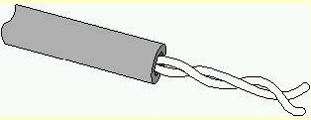

Shielded Twisted Pair Cable

STP cable uses a woven copper-braid jacket that is more protective and of a higher quality than the jacket used by UTP. Figure 2 shows a two-twisted-pair STP cable. STP also uses a foil wrap around each of the wire pairs. This gives STP excellent shielding to protect the transmitted data from outside interference, which in turn allows it to support higher transmission rates over longer distances than UTP.

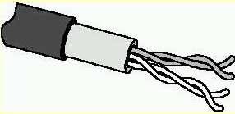

Fig.2 Shielded Twisted Pair Cable

Twisted Pair Cable Connector (RJ45 Connector)

Twisted-pair cabling uses RJ-45 telephone connectors to connect to a computer. The RJ-45 connector houses

eight cable connections. An RJ-45 connector is shown in Figure 3.

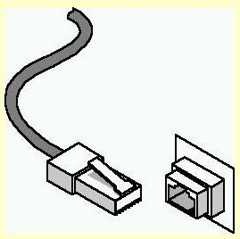

## Coaxial cable

In its simplest form, coaxial cable consists of a core of copper wire surrounded by insulation, a braided metal shielding, and an outer cover. Figure 2.1 shows the various components that make up a coaxial cable.

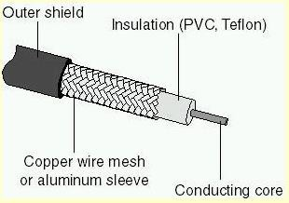

Fig.4 Coaxial Cable

Coaxial Cable Connector (BNC Connector)

Coaxial cable uses a connection component, known as a BNC connector, to make the connections between the cable and the computers. Figure 2.7 shows a BNC connector.

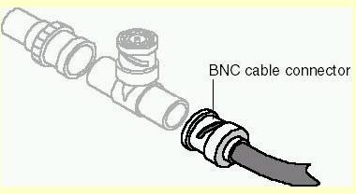

Fig.5 BNC Connector

## Fiber optic Cable

In fiber-optic cable, optical fibers carry digital data signals in the form of modulated pulses of light. An optical fiber consists of an extremely thin cylinder of glass, called the core, surrounded by a concentric layer of glass, known as the cladding.

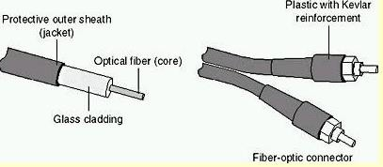

Fig.6 Fiber optic Cable

## Color-Code Standards:

Two wires color-code standards apply: EIA/TIA 568A and EIA/TIA 568B. The codes are commonly depicted with RJ-45 jacks as follows:

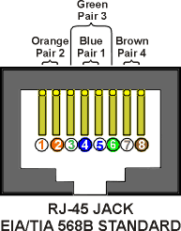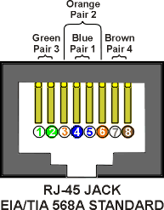

If we apply the 568A color code and show all eight wires, our pin-out looks like this:

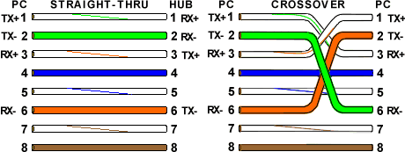

Note that pins 4, 5, 7, and 8 and the blue and brown pairs are not used in either standard.

## II] Network Topologies

**Network topology** is the arrangement of the various elements (links, nodes, etc.) of a computer network. Essentially, it is the topological structure of a network, and may be depicted physically or logically. Physical topology refers to the placement of the network's various components, including device location and cable installation, while logical topology shows how data flows within a network, regardless of its physical design.

**Point-to-point:** Point-to-point networks contains exactly two hosts (computer or switches or routers or servers) connected back to back using a single piece of cable.



**Bus Topology:** In local area networks where bus topology is used, each node is connected to a single cable. Each computer or server is connected to the single bus cable.

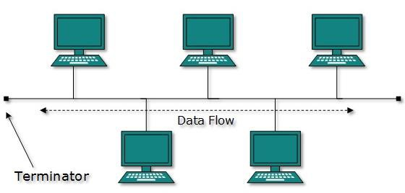

**Star Topology:** All hosts in star topology are connected to a central device, known as Hub device, using a point-to-point connection. That is, there exists a point to point connection between hosts and Hub**.**

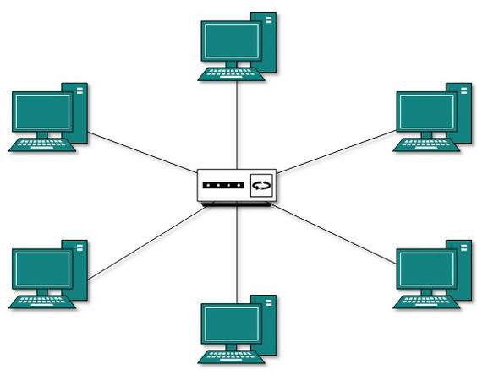

**Ring Topology:** In ring topology, each host machine connects to exactly two other machines, creating a circular network structure. When one host tries to communicate or send message to a host which is not adjacent to it, the data travels through all intermediate hosts.

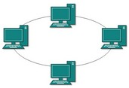

**Mesh Topology:** In this type of topology, a host is connected to one or two or more than two hosts. This topology may have hosts having point-to-point connection to every other host or may also have hosts which are having point to point connection to few hosts only.

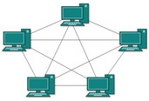

**Tree Topology:** This topology divides the network in to multiple levels/layers of network.

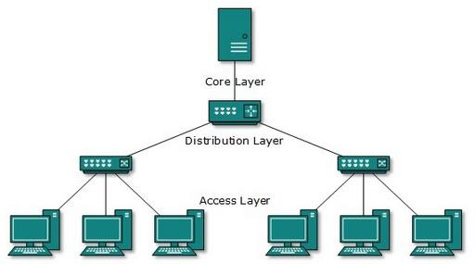

**Hybrid Topology:** A network structure whose design contains more than one topology is said to be Hybrid Topology.

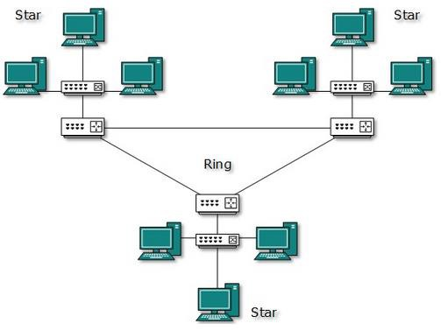

**Experiment working:**

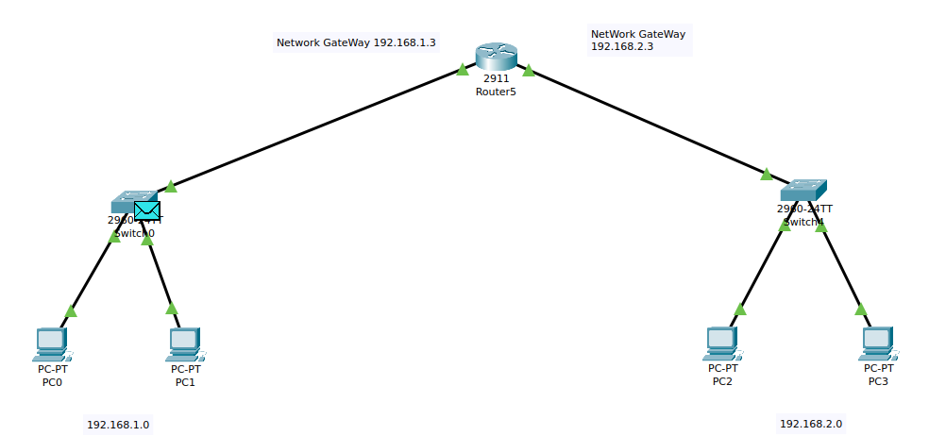

Switch forwarding of ping given to pc 2 as ping 192.168.2.1:

Message forwarded to the router for network gate way from gateway 192.168.1 to 192.168.2

Message forwarded from gateway 192.168.2 router to switch 192.168.2.1

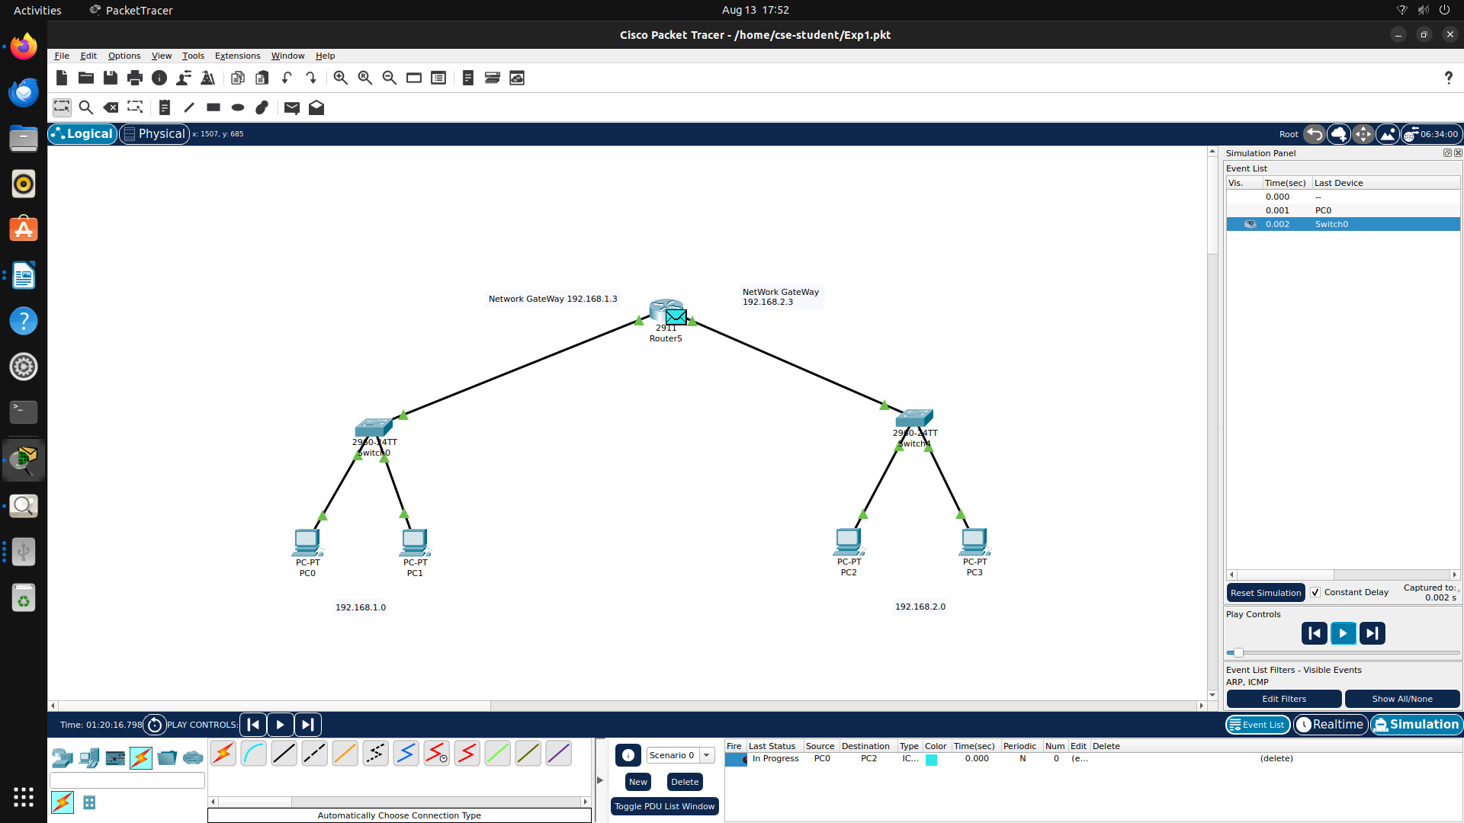

Message Forwarded from a different network Gateway to different switch

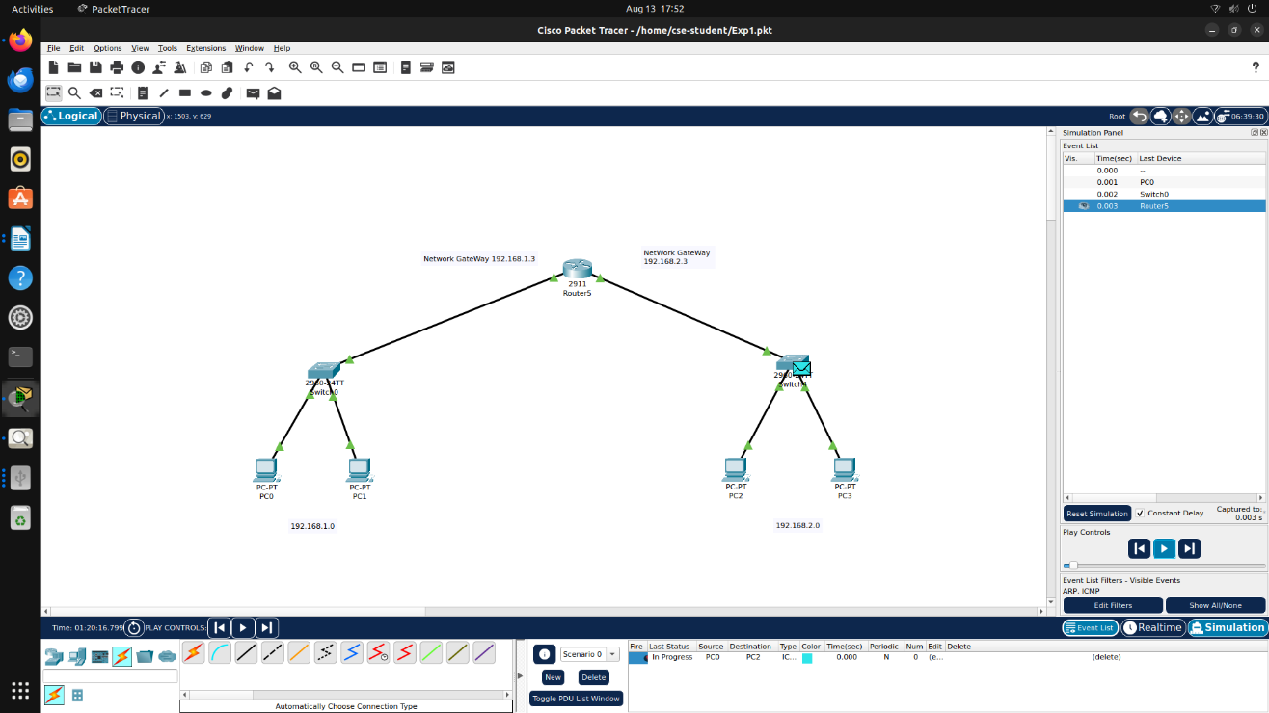

Message then forwarded to the ping pc as 192.168.2.1

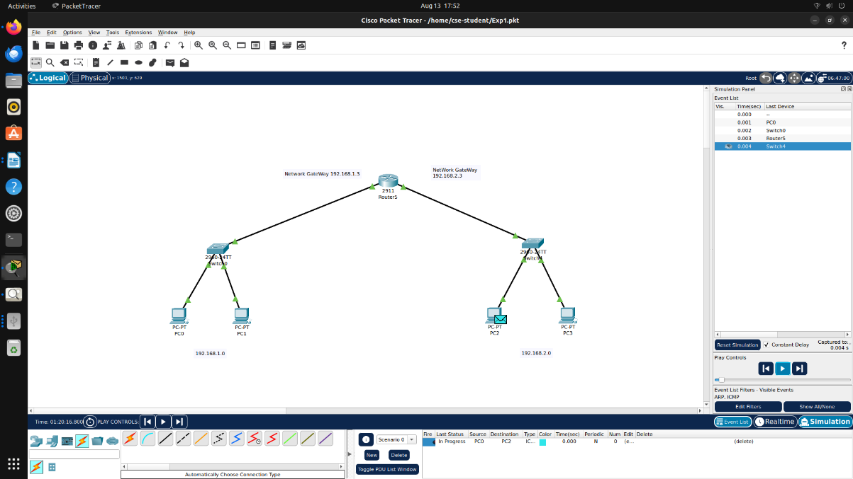

Rerouting of the message from the switch again to the original pc through network Gateway

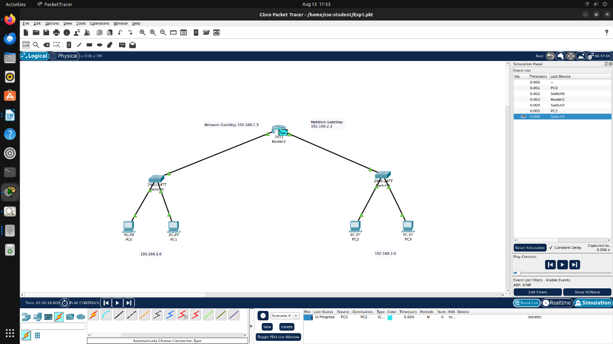

Packet back to the original network via resending

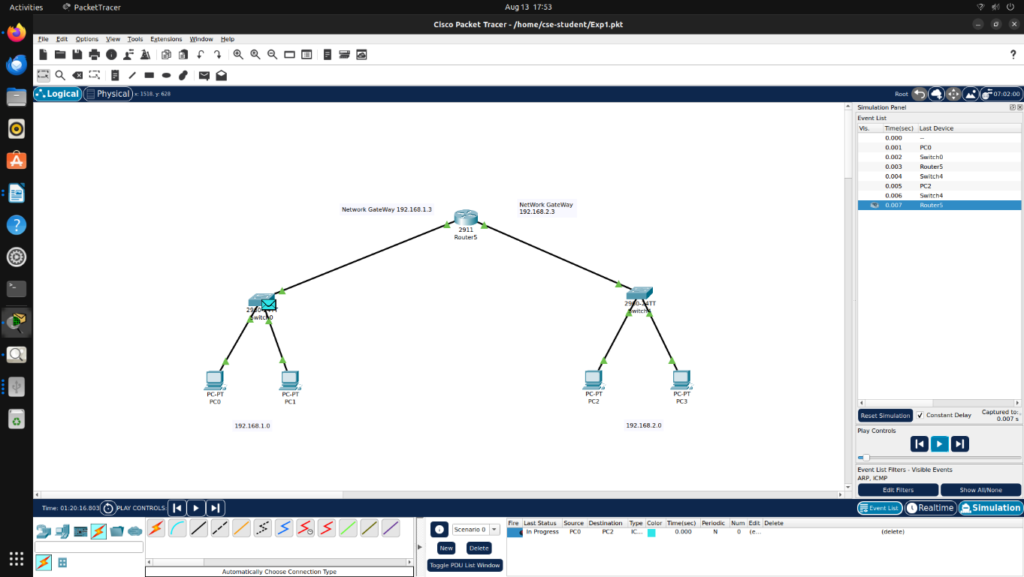

Original pc received the packet

